Validation Study: HES Data Cleaning Actions

Outpatient (OP) Data
1. Missing Specialty (MAINSPEF, TRETSPEF)
Rationale: Ensure specialty fields are complete for Grouper.
Actions:
- If MAINSPEF is missing, copy from TRETSPEF (if valid) for the same appointment for the same patid.
- If TRETSPEF is missing, copy from MAINSPEF (if valid).
2. Both Specialties Missing
Rationale: Ensure specialty fields are complete for Grouper.
Actions:
- If not attended: drop the record.
- If attended: impute missing specialties with the mode.
3. Invalid Specialty Codes
Rationale: Ensure specialty fields are complete for Grouper.
Actions:
- Replace remaining NAs in MAINSPEF and TRETSPEF with their respective mode values, but only for attended records.
4. Handling FIRSTATT == "X"
Rationale: "X" represents missingness, to ensure that its complete.
Actions:
- Select attended == 5 (aligned with OMOP preprocessing by Antonella).
- After checking Grouper, replace "X" with 4 (least resource-intensive category).
In cases where the national_average_unit_cost,field contains a *, this typically indicates suppressed values due to low attendance counts. To ensure consistent cost estimation across treatment specialties (tretspef) and HRG codes (nac_hrg), the following logic was applied:
- For each tretspef and nac_hrg group:
  - If all rows contain suppressed unit costs (*), the average of the available cost values was used as the unit_cost.
  - If some rows have valid national_average_unit_cost values, the unit_cost was calculated using the weighted mean of those values, weighted by number_of_attendances.
HRG Cost Imputation and Clustering Methodology
The dataset was first cleaned to extract relevant variables and flag rows with suppressed national average unit costs (denoted by '*'). These values were converted to numeric format, and attendance figures were similarly cleaned to ensure consistency.
Unit costs were then imputed for each HRG using the following logic:
- Since costs are reported by department description (e.g., Consultant-Led or Non-Consultant-Led), the imputation was performed within each treatment specialty and NAC HRG code.
  - If all rows for a given HRG and treatment specialty had suppressed national average costs (denoted by '*'), the mean of the actual cost column was used.
  - Otherwise, a weighted mean of the national average unit cost was calculated using the number of attendances.
In the OMOP dataset (where the firstatt variable was randomly allocated), HRGs were clustered by the first four characters of their code (e.g., WF01A–D grouped as WF01). Within each cluster:
- If any HRG had suppressed attendance data (denoted by '*'), a simple mean of the imputed unit costs was used for the cluster.
- Otherwise, a weighted mean was applied using the number of attendances.
This approach ensures that HRGs within the same clinical cluster share a consistent unit cost, while accounting for data suppression and variation in activity levels.

Admitted Patient Care (APC) Data
1. Missing Procode3
Rationale: Procode3 is required for grouper classification.
Actions:
- Run grouper with a single batch.
- Validate by checking 20 random valid codes against patients’ actual data.
- If HRG does not change, use these random valid codes to populate Procode3.
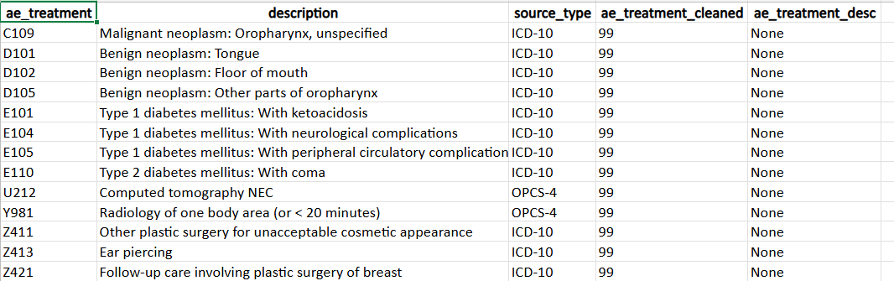

Accident & Emergency (AE) Data
1. Misclassified Treatment Codes (Treatment_01)
Rationale: Diagnosis codes stored in the treatment variable cause misclassification.
Affected Codes: C109, D101, D102, D105, E101, E104, E105, E110, U212, Y981, Z411, Z413, Z421
Actions:
- Confirmed these are diagnosis codes.
- Delete them from the treatment variable.
Cleaning_AE_Treatment_Codes.xlsx

